A Social Assessment
Vietnam: the Social Assistance System Strengthening Project (SASSP)

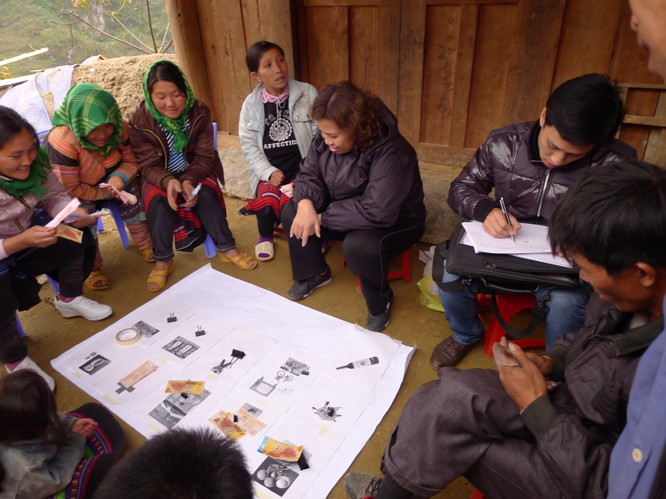

March 2013

Table of Contents

I. Project Description 6
II. Objectives of a Social Assessment 8
III. Methods 9
IV. Background information on the project areas 11
4.1.A poverty profile 11
4.2. Local power relationships and forms of traditional power legitimization 12
4.2.1. Formal institutions 12
4.2.2. Informal institutions 13
4.2.3. Expected changes in the local power relationships 15
4.2.4 Constraints of the traditional leadership 15
V. Findings: Anticipated project impacts 15
5.1. Overall project impacts 15
5.2. Perceptions of positive impacts of existing cash transfer programs and the Opportunity Program 16
5.3. Perceptions of potential adverse impacts of cash transfers 19
5.4. Perceptions of the existing system for social assistance delivery and reforms proposed under the project 21
VI. Recommendations 27
6.1. The culture of dependence and targeting 29
6.2. Communication, outreach, and beneficiary utilization of social services 30
6.3. Payment and spending practices 31
6.4. Monitoring and evaluation 31
6.5. Governance-related issues 32
6.6. Framework for ensuring free, prior, and informed consultation with affected EM communities during project implementation 33
Annex 1: Local Access to Basic Social Services 34
A1. Access to Healthcare Services 34
A2. Access to Education 36
Annex 2: A sample minute of consultation 39

Executive Summary
The design of the SASSP is based on the recognition of the importance of formal social protection given Vietnam’s evolving poverty and vulnerability profile, with an increasing concentration of poverty and low human development outcomes among EM groups and in geographically isolated areas. Reducing fragmentation in social assistance and strengthening the delivery mechanism would make a greater share of resources available to poor children and children from ethnic minorities (EM). There are no potential large scale, significant and/or irreversible impacts of the project interventions identified.
According to Vietnam Household Living Standard Survey VHLSS data, the share of beneficiary households that are from EM background are 96 percent in Hà Giang, 41 percent in Quảng Nam, 56 percent in Lâm Đồng and 33 percent in Trà Vinh in 2010, including major ethnic groups such as Mong, Tay, Dao, Nung (Ha Giang), Co Tu, Xo Dong (Quang Nam), K’ho, Nung, Tay (Lam Dong), Khmer, Hoa (Tra Vinh). As the project is to take place in areas with a high proportion of major EMs, it is important to ensure that the project interventions are designed keeping in mind their specific cultural and social context and to ensure that EM groups are not excluded from project benefits. Therefore, the policy on indigenous people (OP 4.10) is triggered.
Under a social assessment in a broad sense, a variety of free, prior and informed consultations at different levels with different target groups (officials, beneficiaries of the existing cash transfer schemes and potential beneficiaries of the SASSP, Kinh and non-Kinh) were conducted during the preparation stage (see Tables 1 and2). The consultations were conducted with the potential provinces for the project in order to understand potential impacts of the proposed project on beneficiaries and the ethnic minorities communities as a whole. In particular, a service assessment took place in Ha Giang, Quang Nam, Lam Dong and Tra Vinh in November 2012, and a social assessment in Quang Ngai, Lam Dong and Tra Vinh in December 2012, both involving various EM groups. These consultations have been well-documented through various reports, notes and minutes.During the project preparation, the following provinces were selected: Ha Giang, Quang Nam, Lam Dong and Tra Vinh.

The SA solicited feedback through in-depth interviews, focus groups discussions, and visits to selected households. The primary objective of a social assessment is: (i) to confirm whether there is a broad community support for project implementation from target ethnic minorities since most of the project beneficiaries are poor households in areas with a high proportion of ethnic minorities, to identify whether the project would have any potential social impacts (positive and adverse) resulting from the project activities, particularly the planned payment of a small cash transfer to poor households and social work through a network of village collaborators, on ethnic minorities; and (ii) to support the design of the project activities, with a particular focus on ensuring that, in areas where ethnic minorities populations are present, the project interventions are designed keeping in mind their specific cultural and social context and ethnic minorities are not excluded from project benefits. (This objective is critical given that the project is to take place in on areas with high ethnic minorities population). A secondary objective of the consultations was to review the experience of existing cash transfer programs (i.e., under Decree 49, Program 268, Decree 67/13, etc.), with a view to informing project design to address any issues raised.
The consultations indicate that there is broad community support from EM peoples for the proposed project interventions and that the proposed project design will not have any negative impacts on the culture and tradition of EM groups in the project sites. The respondents, including EM groups, viewed cash benefits as timely and useful budget support for EM beneficiary households to improve their children’s access to education, healthcare and nutrition, especially with the assistance of the village collaborator network. The respondents felt that the Opportunity program would have a similarly positive impact on beneficiaries as that of the existing cash transfer programs (i.e., under Decree 49, Program 268, Decree 67/13, etc.).
The SA reviewed the experience of these existing cash transfer programs. Most communities agreed there was widespread local support for cash transfers in reducing poverty and promoting schooling. A streamlined apparatus of state administration, education and health service providers and mass organizations from the central to the grassroots levels, in which a number of EM officials are engaged, has been established to deliver such programs. In several cases, local institutions (including from EM groups) have been engaged to effectively link the local government and different groups. At the same time, many participants in consultations also raised the following concerns about the existing delivery system: (a) poor access to information, with language barriers being cited as the main reason for not participating in community meetings, joining mass organizations, viewing information on the commune bulletin boards or being informed by community chiefs; (b) weak targeting of beneficiaries with perceptions of both exclusion and inclusion errors in the poor list; (c) lack of transparency, predictability and inadequate verification of beneficiaries in payment of cash benefits; (d) weak complaints handling mechanisms due to a lack of understanding the rules and process, especially amongst EM groups, and often apparent distance between local officials and the people; and (e) inadequate monitoring of the programs and lack of availability of monitoring data. Respondents felt that these problems were often exacerbated for EM groups due to cultural or language barriers. For instance, the consultations indicated that the extent to which various EM groups value and utilize education and healthcare services varies, indicating the need for greater communication and support along with the cash transfer.
An additional concern was identified in the consultations with government officials, namely the possibility of dependency of beneficiaries on social assistance. Though local communities did not necessarily support this view, the project addresses this concern through the investment in a network of social collaborators who would be responsible for supporting households in appropriate parenting practices, following culturally appropriate practices, and promoting the use of education and health services. The project design also addresses the specific concerns highlighted by communities by strengthening the social assistance management and delivery system, including mechanisms for improved targeting, beneficiary payments management and support to grievance redress procedures and improved monitoring and evaluation.
The SASSP is a gender-informed project. Data from the VHLSS suggest that gender is not a strong determinant of household poverty in Vietnam and human development outcomes for children do not display strong variations between girls and boys. Instead, there is evidence that EM girls and women are experiencing specific challenges in terms of access to health and education. The reforms supported by the SASSP take these findings into account, particularly in the design and implementation arrangement under Component 2. First, cash transfers under the Opportunity program will be paid to women in their household. The social assessment suggests that women in potential beneficiary households, including among EM groups, keep the household cash and tend to spend more of it on rice, food and foodstuffs and children’s needs, including those relating to education and healthcare. In the study sites, both the husband and the wife typically make a joint household decision on the use of cash benefits. Second, the program would mobilize women as social collaborators and beneficiary women as program collaborators and parent leaders, to encourage their participation in community groups and support women’s leadership and community action. The social assessment indicates that potential beneficiaries among mothers‘ groups are not concerned that their participation would cause impacts on their household workload or would be a source of tension at the household or community levels
In sum, community households acknowledged that the project interventions would support to improve the current social assistance system. In fact, in areas where some elements of the proposed reforms (e.g. cash transfer payments through an independent payment agency) have been tested, the majority of stakeholders reported satisfaction with the levels of transparency, convenience and safety. As a result, according to the information gathered from respondents,they showed their agreement with SASSP’s impacts on welfare and long-term poverty reduction, especially amongst EM groups.
- Project Description
Vietnam’s economic and social transitions from a low to a middle income country, from an agricultural to an industrial economy and from a young to an aging society are focusing the attention of policy makers towards systematically strengthening the formal social protection system. Formal social protection, including social assistance, has been increasingly replacing traditional informal intra-family or community support mechanisms as the latter weaken due to migration and the transition from extended, multi-generational families to nuclear ones. While Vietnam’s traditional formal poverty reduction policies emphasized in-kind and geographically-targeted programs addressing structural sources of poverty in remote regions, the use of household- and individual-based cash transfer programs has substantially expanded over the last few years. However, a close examination of Vietnam’s current formal social protection and poverty reduction system reveals important policy and implementation gaps that risk hampering long-term poverty and vulnerability reduction. Moreover, delivery systems for social assistance and household-based poverty reduction programs are weak, resulting in ineffective service delivery.
Vietnam’s social protection system today suffers from fragmentation of multiple poverty reduction and social assistance programs with overlapping objectives but separate budgeting and delivery mechanisms. There are about a dozen additional cash transfer programs, both regular and one-time. These include most prominently (i) monthly cash support to the disabled, orphans, single parents and lone elderly without means under Decree 67/2007/ND-CP, amended by Decree 13/2010/ND-CP, (ii) a small monthly cash transfer to poor households to offset recent increases in energy prices (both delivered through local social officers) under Decision 268/2011/QÐ-TTg, and (iii) a cash transfer to children from poor households in school for nine months per year delivered through the education system (school principals) under Decree 49/2010/ND-CP. In 2013, a new program was developed to give additional education support to high school students in remote and difficult areas (under Decree 12/2013/ND-CP). This fragmentation creates considerable inefficiency both from the perspective of the implementers and the beneficiaries.
At the same time, the system does not provide adequate protection. Benefit incidence analysis on the basis of the 2010 VHLSS shows that the main existing social assistance programs have limited coverage of the poor, considerable leakage to the non-poor and low benefit adequacy.For example, in 2010, only 24 percent of bottom quintile households were covered by the education subsidy and 12 percent by Decree 67/13. At the same time, 43 and 54 percent of spending under these programs respectively accrued to bottom quintile households. The education subsidy and Decree 67/13 accounted for 4 and 17 percent of consumption of bottom quintile households.
Recognizing changing needs and increasingly binding constraints, Vietnam is increasing its efforts to strengthen key elements of its social protection system including non-contributory social assistance.In 2012 the Central Committee of the Communist Party of Vietnam (CPV) adopted Resolution 15/NQ-TW on “Major Issues in Social Policies of the Period 2012-2020” to help ensure by 2020 a “guaranteed minimum level in income, education, health care, housing, clean water, and information and communication, thus contributing to gradual improvements in incomes and ensured safe, equitable and happy life for the people”. The Resolution specifically highlights the need to consolidate and modernize the management of programs and policies, including with modernized payment mechanisms and with an integrated beneficiary database, to ensure less fragmentation and overlaps of programs. The vision of the Resolution has several implications. First, the role of social assistance in the poverty reduction policy framework for the next five-year plan (2016-2020) is set become considerably more prominent. Second, the new poverty reduction framework will allow for a change in the mix of programs and a consolidation of the current multiple cash transfer programs into fewer ones.
The SASSP will support the efforts by the Ministry of Labor, Invalids and Social Affairs (MoLISA) to implement Resolution 15 in developing solutions for social assistance system modernization and consolidation of programs and processes. It will also initiate the modernization process in four provinces. In doing so, the project is expected to lay a solid foundation for further program consolidation and deployment of a modern delivery system in all 63 provinces across Vietnam during the period of the next five-year plan (2016-2020).
The project has three components: Component 1 will help put in place critical elements of a strengthened management and delivery system for social assistance. Component 2 will support the testing of the strengthened system through a consolidated social assistance program (named the “Cơ hội thoát nghèo truyền kiếp” or “Opportunity to move out of inter-generational poverty” program; “Opportunity program” in short) in four provinces for three years (Hà Giang, Quảng Nam, Trà Vinh, and Lâm Đồng). This program will replace three existing social assistance cash transfer programs. Component 3 will provide support for program management and capacity building.
- Component 1: Support to social assistance and poverty reduction system strengthening ($32m).Project activities under component 1 will help build and test more robust delivery mechanisms for social assistance and strengthen performance monitoring, which will be the basis for promoting program consolidation. This includes the following activities at the national level: (i) support to developing a national registry (i.e., a national database of potential beneficiaries of social assistance programs) including digitization of information of officially poor and near-poor households across all provinces; (ii) developing an integrated MIS for social assistance programs for nationwide use; (iii) promoting program and process consolidation and strengthening service delivery through redefined operational processes, a new payment mechanism with an independent professional agency, and management arrangements based on the new integrated MIS as well as field-based process monitoring; and (iv) support for policy, research and communication and outreach as well as comprehensive change management in order to build broad-based consensus for rolling out these reforms across all provinces. The project will develop these system improvements nationally and test these using the pilot in four pilot provinces. This component will also finance the administrative costs for implementing the Opportunity Program in four pilot provinces, including the use of an independent agency for making benefit payments, and the network of social collaborators. Finally, the project will support the remaining provinces in putting in place the necessary preconditions (guidelines, training, software and hardware) to utilize the strengthened system for social assistance management and delivery in a phased manner.
- Component 2: Support for the launch of a consolidated social assistance program (US$ 25m).Component 2 will support the launch of the consolidation process through the introduction of the Opportunity Program in the four pilot provinces. Approximately 210,000 poor households with children aged 0-15 will be provided a consolidated monthly benefit over three years (2016-2018) in these provinces. The Opportunity Program is designed to help parents make better health, nutrition and education decisions for their children that will help reduce inter-generational transmission of poverty. Component 2 will provide gap financing for benefits payments under the Opportunity Program (i.e., in addition to the government budget provision for the programs being replaced) for a period of three years in the pilot provinces. The financing shortfall between the government budget for the existing programs for three years in the four provinces (US$92m) and total estimated cost of the Opportunity Program (US$117m) is due to the expanded coverage of the Opportunity Program. The gap financing of US$25m under Component 2 represents 21 percent of the estimated cost of the Opportunity Program in the four provinces for three years. The program will be implemented in the third year of the project, once MIS capabilities and other elements of the strengthened delivery mechanism are in place.
- Component 3: Program Management (US$3m).This component would support the establishment of a Central Project Management Unit (CPMU) and four Provincial Project Management Units (PPMUs) to oversee the development of modern delivery systems, coordinate the consolidation of social assistance programs, manage and monitor the implementation of the Opportunity Program and ensure appropriate fiduciary controls are in place. This component would also support regular monitoring of project performance as a whole, including preparation of progress reports and audits. At the sub-national level, the project will rely on the PPMUs and the existing provincial, district and commune committees for program implementation and monitoring. The intent is to mainstream SASSP implementation as part of regular tasks and program delivery rather than create separate project management units.
The project design has benefited from a partnership between MOLISA, and its technical working group, and UNICEF, DFID and the World Bank. This partnership will continue and the SASSP will be complemented by further technical assistance financed by UNICEF and UK DFID. This will allow providing necessary start-up assistance and capacity building even prior to SASSP effectiveness.
- Objectives of a Social Assessment
As the project is to take place in areas with a high proportion of ethnic minorities, it is important to ensure that the project interventions are designed keeping in mind their specific cultural and social context and ethnic minorities are not excluded from project benefits. Therefore, the policy on indigenous people (OP 4.10) is triggered, which requires the project design to ensure that these groups will not be excluded from accessing the project interventions. As a majority of beneficiaries are households with children from ethnic minorities groups, a stand-alone Ethnic Minority Development Plan (EMDP) for the project as a whole was not prepared. However, key elements typically required for an EMDP were considered and integrated into the overall project design, including cultural and socio-economic characteristics specific to ethnic minorities people, as discussed in Section 6 below (Recommendations).
The primary objective of a social assessment is:
- to confirm whether there is a broad community support for project implementation from target ethnic minorities since most of the project beneficiaries are poor households in areas with a high proportion of ethnic minorities, to identify whether the project would have any potential social impacts (positive and adverse) resulting from the project activities, particularly the planned payment of a small cash transfer to poor households and social work through a network of village collaborators, on ethnic minorities; and
- tosupport the design of the project activities, with a particular focus on ensuring that, in areas where ethnic minorities populations are present, the project interventions are designed keeping in mind their specific cultural and social context and ethnic minorities are not excluded from project benefits. This objective is critical given that the project is to take place in on areas with high ethnic minorities population.
A secondary objective of the consultations was to review the experience of existing cash transfer programs (i.e., under Decree 49, Program 268, Decree 67/13, etc.), with a view to informing project design to address any issues raised.
- Methods
Under a social assessment in a broader sense, a variety of free, prior and informed consultations at different levels with different target groups (officials, beneficiaries of the existing cash transfer schemes and potential beneficiaries of the SASSP, Kinh and non-Kinh) were conducted during the preparation stage (see Tables 1 and 2). The consultations were conducted with the potential provinces for the project in order to understand potential impacts of the proposed project on beneficiaries and the ethnic minorities communities as a whole. In particular, a service assessment took place in Ha Giang, Quang Nam, Lam Dong and Tra Vinh in November 2012, and a social assessment in Quang Ngai, Lam Dong and Tra Vinh in December 2012, both involving various EM groups. During the project preparation, the following provinces were selected: Ha Giang, Quang Nam, Lam Dong and Tra Vinh. A variety of techniques were used, including key informant interviews with semi-structured questionnaires with key stakeholders from the provincial to the village level, FGDs with respondents, including beneficiaries and non-beneficiaries from diverse ethnic groups,simulation exercises for spending practices and preferences, and field observations. Interpreters were provided in necessary cases. The team took into account the principle of ensuring free, prior and informed consultation with the ethnic minorities groups in the project areas. In addition, the performance of existing cash transfer programs in the study sites was reviewed through both primary and secondary data. Finally, larger-scale consultative workshops with government representatives (central, provincial, and district) have been held in different areas across the country, vis-à-vis Hanoi, Quang Nam,and Lam Dong. These consultations have been well-documented through various reports, notes and minutes.
Table 1: Details of consultations
Techniques | Location and time
Techniques | Hà Giang  (Nov.5-11, 2012) | Quảng Nam  (Nov. 7-12, 2012) | Lâm Đồng  (Nov. 15-21, 2012) | Tra Vinh  (Dec. 12-17, 2012) | Quang Ngai  (Dec. 18-22, 2012) | Lao Cai  (Dec. 23-28, 2012)
Key informant Interviews | 6 | 5 | 6 | 6 | 5 | 6
FGDs | 12 | 8 | 12 | 13 | 13 | 13
Consultative workshops |  | 1 | 1 | 1 | 1 | 1

Table 2:Breakdown of the respondents of the Social Assessment in Tra Vinh, Quang Ngai and Lao Cai by gender and ethnicity (December 2012)
No |  | TRA VINH |  |  |  |  | QUANG NGAI |  |  |  |  | LAO CAI
No |  | Total | Male | Female | EM | Poor | Total | Male | Female | EM | Poor | Total | Male | Female | EM | Poor
1 | Provincial level
 | Government officials | 10 | 8 | 2 | 0 | 0 | 9 | 8 | 1 | 0 | 0 | 7 | 5 | 2 | 1 | 0
2 | District level
 | Government officials | 13 | 11 | 2 | 2 | 0 | 6 | 5 | 1 | 0 | 0 | 8 | 8 | 0 | 2 | 0
3 | Commune
 | Government officials | 33 | 23 | 10 | 3 | 0 | 25 | 17 | 8 | 18 | 0 | 36 | 22 | 14 | 26 | 0
4 | Village level
 | Government officials | 13 | 12 | 1 | 11 | 0 | 21 | 17 | 4 | 21 | 0 | 12 | 9 | 3 | 12 | 0
 | Villagers | 61 | 15 | 46 | 59 | 44 | 48 | 15 | 33 | 47 | 47 | 38 | 11 | 27 | 38 | 22
 | Total | 130 | 69 | 61 | 75 | 44 | 109 | 62 | 47 | 86 | 47 | 101 | 55 | 46 | 79 | 22

- Background information on the project areas

4.1.A poverty profile

By late 2010, Ha Giang had counted 63,453 poor and 21.288 near-poor households, representing 41,8 and 14,02 percent of its total number of households, respectively. Out of the 63,453 poor households, as many as 62,676 were from EMs, making up 98,78 percent of the total. Poverty is concentrated in six mountainous districts, with 45,621 poor households, accounting for 61.5 percent of the total household population. However, according to the official reports, by late 2012, the number of poor households had declined by 15,442, thus the poverty rates had decreased to 30.1 percent. Especially, in these mountainous districts, the number of poor households had declined by 9,714, thus the poverty rates had decreased to 45.8 percent, in the same period. Ha Giang is the poorest of the four selected provinces but 87.7 percent of its roads to commune centers have been asphalted. All communes and wards have been connected to the national electric grid, with 78 percent of the households having access to electricity. As many as 98 and 92 percent of the provincial areas have been covered with radio and television waves, and 66 percent of the households possess TVs, and 87 percent of the households can watch TV. All communes have been covered with the telecommunication network.
In Quang Nam, the poverty rates of three poor districts under Programme30A (Tay Giang, Phuoc Son and Nam Tra My) decreased from 57.5 percent in 2008 to 48.5 percent in 2010, registering an annual decline of 4.5 percent. The poverty rates in 57 poor communes with extreme economic hardships and under Programme 135, Phase II, have decreased significantly, from 66 percent in 2006 to 47 percent in 2010, an annual decline of 4.7 percent. However, this decrease failed to meet the set target under Programme 135 (less than 45 percent by late 2010). The poverty rate in 21 poor communes with extreme economic hardships in sand-bar areas under Programme 257 had declined rapidly and surpassed the target: the rate decreased from 31 percent in 2006 to 12 percent in 2010, an annual decline of 4.7 percent.
In Lam Dong, the EMs represent 54.6 percent of the total poverty rates. The local authorities have taken many measures to encourage poor people to escape from poverty by themselves. Beneficiaries from the state-funded poverty reduction programmes are required to make commitments on efforts to escape poverty. Lam Dong has also funded its own investment schemes in poor communes according to the local criteria.
In Tra Vinh, by December 2011, the poverty rate had been 20.13 percent. The poor Khmer accounted for 53.18percentof the total poor population in the province and 33.68 percentof the total Khmer population. The provincial near-poor rate was around 10percent of the total household population, with nearly 45 percentbeing Khmer households. The main livelihoods amongst the Khmer include casual employment with unstable incomes.Many poor Khmer migrants to urban areas have brought along their children, whichmay discontinue the latter’s education.But many of the Khmer in Tra Vinh do not face language barriers, whileIn other visited areas, the rates of EM people who are unable to speak nor write Vietnamese remain high, resulting in considerable barriers in communication, especially in accessing necessary information on poverty reduction and social assistance programmes.

Table 3. Thepoverty and near-poverty rates(updated by late 2012)
Province | Total  hh pop | Poor |  |  |  | Near poor
Province | Total  hh pop | Poor hh  (number) | PR  (%) | EM poor hh  (number) | EM PR  (%) | Near poor hh  (number) | Near PR | EM near poor hh  (number) | EM near PR
Ha Giang | 159,325 | 48,011 | 30.13 |  |  | 20,598
Quang Nam | 380,211 | 79,482 | 24.18 |  | 5.81 | 53,447 | 14.02 |  | -
Lam Dong |  |  | 9.36 |  | 23.88 |  | 6.07 |  | 13.69
Tra Vinh |  |  | 20.13 |  | 53.18 |  | 14.17 |  | 18.16
Source: The local capacity assessment, ILSSA, 2012.
  - Local power relationships and forms of traditional power legitimization
The formal and informal institutions described below reflect the existing power relationships and different forms of power legitimization amongst the researched EM groups in the project sites. This section examines the expected changes in the existing power structure and constraints in the traditional leadership in relation to the SASSP.
    - Formal institutions
- Village conventions and power relationships: Village regulations, endorsed by the district authorities, include those that maintain social order, ensure environment hygiene and new-style cultural practices within a village framework in accordance with conventional practices and customs of different ethnic groups within the same community. The village administration is represented by the people’s management board and the self-governing units (also known as vel in the Khmer language) which resemble agricultural cooperatives under the central planning economy. Village regulations are built on the existing legal system and in accordance with the local ethnic traditions and customs. The village administration is the same across the country but local capacities may vary. Village cadres are better-educated, with more understanding of government documents, and more efficient communication in Vietnamese in some areas than in others.
- Village elderly: Amongst the H’mong community, ‘new-type’ village elderly are elected every two years (at the election of the village head) and endorsed by the Government. In Lung Vai II village which accommodates many ethnic groups, ‘new-type’ village elderly play a very weak role. Therefore, an elderly who may be respectful for one group may not be so for others, which makes his role practically inefficient.
- Regulations and working statues of socio-political organizations such as the Fatherland Front, and different cells from the Farmers’ Association, the Women’s Union, the Veterans’ Association, the Senior Citizens’ Society, and the Youth’s Union apply at the village level.
- The People’s Mobilization Panel is a new institution in the village power structure. The board is held accountable for providing support for the National Program on Building New-Type Rural Areas.
- The Reconciliation Panel stipulates rules and procedures to settle emerging conflicts amongst villagers. Under these rules, in case of such emerging conflicts, the concerned parties are required to settle with each other in the first place. If they fail to reach an agreement, their case shall be handled by the village-level reconciliation panel, led by the Head of the People’s Panel, or the Head of the Fatherland Front in coordination with representatives from mass organizations or village leaders (in the case of the Co group). Membership usually includes police officials, leaders of Farmers’ Union, Women’s Union and a village elder (known as “gia lang” or “plok palei” in the case of the Co group). If the conciliation does not work out, the case shall be submitted to the Commune’s People’s Committee or the higher-level authorities, to be settled according to the Vietnamese laws.
- In addition to women’s and farmers’ popular micro-finance groups are rotary funds managed by the village cell of the women’s union. The funds stipulate the use of cash contributions from village women to provide assistance for local households in production and poverty reduction.
    - Informal institutions
- The kinship network: The ethnic customs and conventional practices stipulate behavior codes within thân tộc (three consecutive generations in the paternal kinship) and thích tộc (three consecutive generations in the maternal kinship). The heads/the oldest/the senior people in the family maintain an important voice in changing behavior of their kin.
- Traditional village relations: In Lung Vai II village, each of the many existing different groups still keeps all of its customs and habits. However, the traditional role of village elderly among the H’mong group has changed in some areas and the extent of change may vary. The elderly in Nan Tieu Ho village play a very important role in the community, especially in its spiritual life. Great importance is attached to Land Genie/Forest Genie credence, and yearly kowtow ceremonies (3/3; 5/5; 15/7; 15/8; new rice worship, Lunar New Year). Value for social cohesion plays an important role amongst the H’mong communities. A majority of poor households in Lung Vai II village want to escape poverty because they are “ashamed for being criticized in every meeting”.
- The traditional Palei relationships and community values: The Co people used to live together in a long house, with many kitchens, each representing a household. There were only several long houses in one village, called as “palei”. Each house was divided into many compartments. Each compartment became a private living space for one couple and their small children. After 1975, the long stilt houses were separated into stand-alone ones for couples and their children or for three-generation families. However, the relationships of family members and neighbors are still the major bonds within communities. They maintain close family relationships within the paternal group (the three consecutive generations on the father’s side) and the maternal group (the three consecutive generations on the mother’s side). Plok Palei used to play a critical role in social cohesion, from productive activities and maintenance of social hierarchy to the preservation of cultural values of the communities. Nowadays, Plok Palei mainly participates in mediation, policy dissemination and traditional religious activities.
- The practices of labour exchange (đổi công) and alternate work (vần công), rewarded cow raising(nuôi rẽ bò) and rewarded fieldwork (cấy rẽ ruộng) serve as cooperative forms in production. Alternate work is a form of cooperation amongst many households by which households concentrate their labour to handle fieldwork in turns, from one to another. Meanwhile, labour exchange is a different form of cooperation between two households by which they work for each other and receive an equivalent number of man-days in return when either of them needs. Rewarded cow raising is a rather common form of cooperation. Initially, poor people take care of cows for their owners. If the cows give births, the former can keep the first calf, and the latter the second. At present, the division of outputs is made in cash equivalent: if the cows give births, calves are sold for cash which is halved between the owner and the hired cow-raiser. In hired fieldwork, poor farmers take charge of arable field for landlords and annually remit part of their paddy rice to the latter. The practices of labour exchange and alternate work are maintained within the Palei community, especially in the “an hem than” – the maternal group.
- Primitive beliefs are related to agriculture and annual production cycles as “cung phat ray” – ceremony of land clearing, “cung tria lua” – ceremony of seed planting, “cung com moi” – ceremony of harvesting “new rice”; “ cung nga ra” - celebration in the end of the year; “le an trau” – a ceremony praying for prosperity, organized by one household and joined by the whole palei community. In addition, the Khmer in Tra Vinh enact rules on cultural practices regarding worship of genies (niê tà) and ancestors.
- The Buddhist culture and pagodas: Theravada Buddhism and Buddhist moral principles have made profound impacts on the Khmer community in Tra Vinh. In addition to the rules on worship are behavioral codes to reflect the Khmer good will and reciprocal support. The pagoda management is headed by Nhôm vót (the Pagoda Father) who is elected by Buddhists and supposed to assist monks in managing pagoda work, such as capital construction and organization of annual ceremonies. Wuện is a residence-based Buddhist institution within a village, providing assistance to local people in practicing household Buddhist formalities. “Săng khum” is a form of cash pooling for reciprocal support in cases of risks, such as labor accidents, sickness and death;
- Village shops and informal credit system: Within the H’mong communities in the North, some private lenders for farming activities provide technical support for cultivation and outlets for local people. In the Central Region, the Kinh people own most of the shops and stores in the areas inhabited by the Co people. Commodities traded include fertilizers, pesticides, rice, salt, and other essential goods. Most Co people buy on credits and repay in the harvest seasons with their farming products (maize, cassava, cinnamon or acacia, etc.) or with cash at a pre-agreed but usually very high interest rate. Amongst the Khmer in Tra Vinh, village shops and informal credit system operate with regulations on different forms of lending and buying on credit, usually with very high interest rates;
    - Expected changes in the local power relationships

Below are some expected changes in the local power structure as a result of the SASSP, as described by the respondents from the consultations.
- More power is expected for women in the household decision making in comparison with their conventional roles;
- More purchasing power is expected for beneficiary households, especially poor women, as a consumer (with more disposable incomes);
- EMs and poor women are expected to be empowered in social work as programme collaborators vs conventional roles confined to households;
- The roles of village key stakeholders (village heads, elderly) are expected to become more active as they are supposed to be engaged more in the project activities through the linkage role of the village collaborator;
- The existing power structure at the village level may be used more strategically and effectively for project activities, such as C4D and the strengthened feedback mechanism; and
- Dependence of beneficiary households on the informal credit system with many foreseen risks may be lessened.

4.2.4 Constraints of the traditional leadership
- All village heads and elderly who are supposed to be respected and whose voice is more influential should be men who may not be gender-sensitive enough to women beneficiaries, especially in communication and mobilization;
- The conservative roles of the head of the kinship network may also make the application of the project initiatives more difficult; and
- Village heads, elderly and heads of the kinship network are essential in many aspects of the community but many of them do not have a good command of the Vietnamese;
These constraints have been taken into account at the design stage. In particular, (female) village collaborators who should have a good command of Vietnamese and EM languages will be employed, amongst other assignments, to support traditional leaders to effectively enhance their roles and performance relating to the project delivery. A tailored C4D strategy, which is being prepared, may also provide measures to address these constraints of traditional leaders in order to maximize their advantages in outreach and communication.
- Findings: Anticipated project impacts

5.1. Overall project impacts
The social assessment confirms that the project impactsare overall positive, and there are no adverse impacts envisaged at this stage.
Among households and communities: There is broad community support, including from ethnic minority peoples, from the project areas for the project activities. As indicated through consultation, given prior experience with cash transfer schemes, respondents, including potential beneficiaries and non-beneficiaries, indicate their concurrence over the project’s potential positive impacts on immediate welfare and long-term poverty reduction amongst the project’s beneficiaries, including those who come from ethnic minority groups. The respondents, in particular, viewed cash benefits as a timely and useful budget support for poor households, especially those who are from ethnic minority groups, to improve their children’s access to education, healthcare and nutrition. Peoples consulted (through in-depth interviews and focus group discussions) also foresee the project interventions would make an improvement to the current fragmented and inefficient social assistance system. In fact, in areas where some elements of the reforms proposed under the project have already been tested (e.g. cash transfer payments done through an independent payment agency for social insurance), stakeholders (including beneficiaries) report greater satisfaction in the levels of transparency, convenience and safety.
Among government officials: The various consultative workshops and field observations also indicate there is consensus among government officials for the system strengthening and consolidation agenda supported by SASSP and full support for the proposed project design.
The specific findings from the consultations are described below.

5.2. Perceptions of positive impacts of existing cash transfer programs and the Opportunity Program
This section describes respondents’ perceived impacts from the existing CT schemes, especially the ones to be consolidated under the SASSP (including the D49 and D268 benefits), and also some additional impacts anticipated from the Opportunity program introduced by the SASSP.
In many of the free, prior and informed consultations with the ethnic minorities groups in the project areas, it is widely acknowledged that favorable conditions in implementing cash transfer schemes have been existing in the project sites. While reviewing actual impacts of the existing cash transfer schemes, respondents indicate favorable local conditions for project implementation and highly appreciate the positive impacts. The favorable conditions include the support from the local people in general and existing (and potential) beneficiaries in particular. The existing projects have engaged local political institutions, particularly those from indigenous ethnic communities, such as H’Mong, Tày, Nùng, Giáy, Co, K’ho and Khmer. A streamlined apparatus of state administration and mass organizations from the central to the grassroots levels, in which a number of ethnic minorities officials are engaged, has been established. The ethnic minorities officials serve as active agents who can effectively link the local government and the people in different domains, and can provide assistance for Kinh colleagues in policy implementation. Higher-level instructions on operations and responsiveness to public concerns have been provided from the local socio-political institutions. In most cases, commune officials and key village collaborators have a good knowledge of beneficiaries. In a number of ethnic minorities communities, such as those in Ha Giang and Quang Ngai, the existing cash transfer schemes have been strongly supported by heads of ethnic clans, village elders (known as plok palei amongst the Co group) and other informal institutions. The local people maintain good relationships in the spirit of ethnic unity, family and community.
The respondents share a view that the quality of basic social services, which is referred to local physical and human resources, has been improved substantially although more is required. The extent to which various ethnic minorities groups value and utilize education and healthcare services varies. A good awareness of the importance of education and healthcare can serve as a very fundamental advantage in delivering cash transfers to enhance the use of public social services. Tay, Nung, Giay and Khmer people have increasingly better awareness of accessing education and healthcare services than other ethnic minorities in the visited sites. In addition, some Co people living near district and commune centers are better aware of their access to education and healthcare than their fellows in disadvantaged areas. Some Co people in Tra Hiep commune, Quang Ngai, do not have trust in the public healthcare system but seek help from spiritual masters in treatment of diseases. However, in many visited areas, the latter practice is believed to happen much less frequently than in the past. More detailed breakdown of the availability of and access to basic social services in Ha Giang, Quang Nam, Lam Dong and Tra Vinh can be found in Annex1 at the end of this report.
In many villages, the groups representing poverty-escaping, average and well-off households show their complete support to the government's cash transfer schemes:
“Many poor households who have made efforts and save for their children’s schooling in an attempt to escape poverty” (an in-depth interview in Tieu Can district, Tra Vinh).
The simulation exercises indicate that beneficiary households have spent significant shares of their cash benefits on the child’s welfare, particularly on food, education and clothing. It is expected that the village collaborator, who will be employed and trained under the SASSP, will play an important role in promoting right messages to increase the positive impacts of the cash benefits towards the programme objectives. In addition, simulation exercises with current and prospective beneficiaries provide good indicators of potential impacts of the proposed projects.
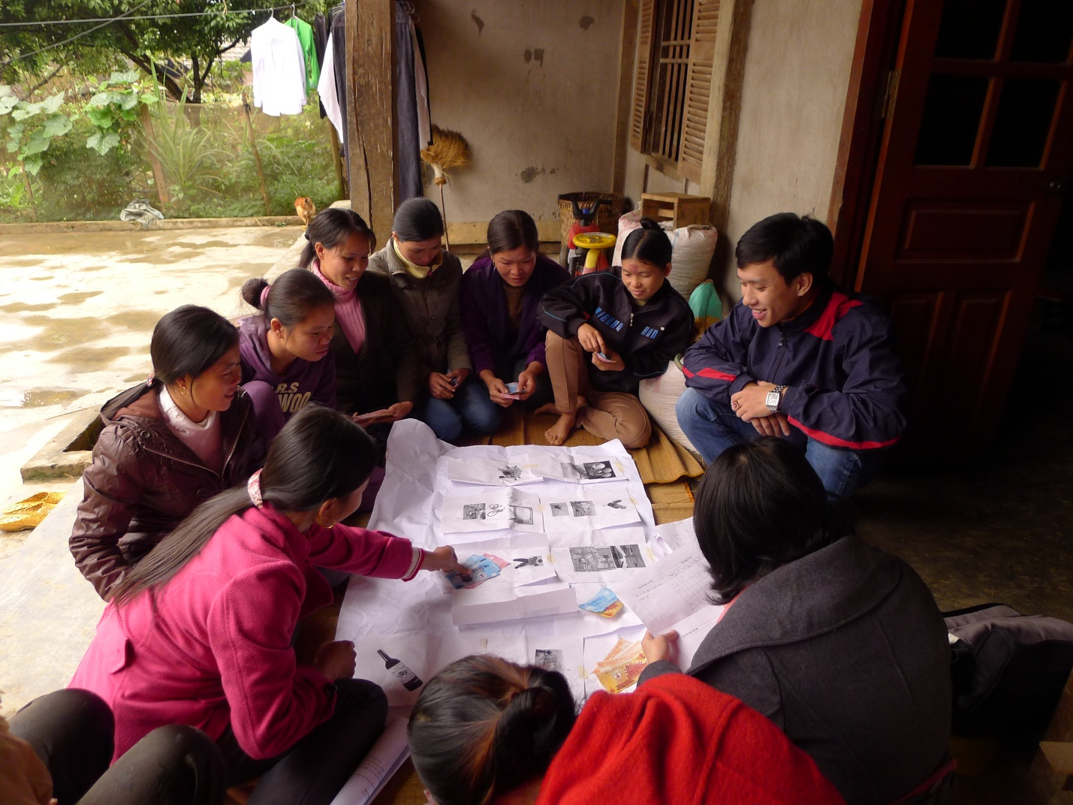
Photo 1: A simulation exercise with potential ethnic minorities beneficiaries on their spending cash benefits.
Human resources are believed to have been improved through better access to education, healthcare and nutrition. In particular, some education outcomes have been acknowledged, including improved diligence of indigenous ethnic minorities students in general and, particularly, reduced school dropout rates amongst the ethnic minorities groups usually found with high dropout rates, such as Hmong, Co and Khmer. These impacts are believed to make further contributions to the universalization of primary education in order to achieve the targets of new rural development schemes:
“The dropout rate reduced considerably thanks to the monthly cash support from the government (70,000 VND per month). The schooling rate was very low in the past, as most of the students' parents were poor. Many of parents could not even afford unworn clothes for their children. They no longer have to work about such things and are provided with free course books, and thus feel more motivated for studying.”(In-depth interview with a commune official in Tra Thuy, Quang Ngai)
It is also widely believed that with the current tangible outcomes, including reduced casual hunger, poverty will be mitigated in the visited sites in the long run. Apart from the positive impacts on human development, as mentioned above, cash benefits are viewed as useful and timely budget support for beneficiary households to change or find their livelihoods, which is believed to have stabilized living conditions of the poor.
As an indirect impact of the cash transfer schemes, it is acknowledged in the consultations, although more widely amongst local officials, that public trust in the Communist Party and the Government has been enhanced. In some areas, such as those in Ha Giang and Tra Vinh, respondents allude to other positive impacts, including maintained social stability, narrowed gap in incomes and expenditures between poorer and better-off households, and reduced child labour.

5.3. Perceptions of potential adverse impacts of cash transfers
During all the free, prior and informed consultations, respondents, whether they be officials or ordinary people or they come from Kinh or ethnic minorities, believe that the proposed project design will not make negative impacts upon the culture and tradition of the ethnic minorities in the project sites. Rather, the project is believed to produce positive impacts, especially those on poverty reduction, within these ethic groups.
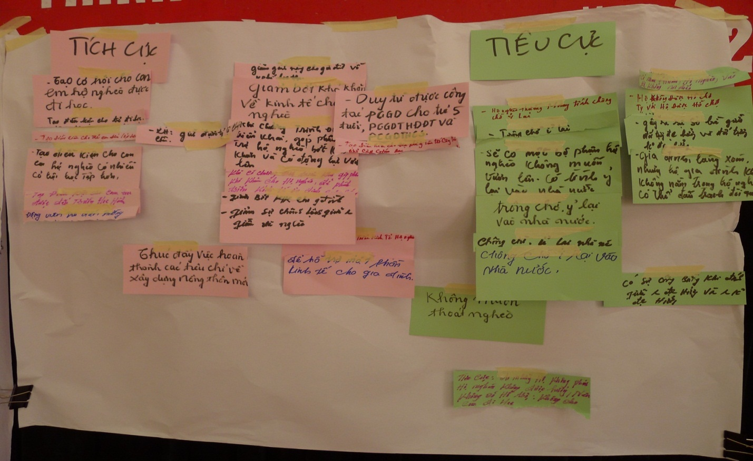
Photo 2: A consultative session on perceived impacts of cash transfers on the ethnic minorities communities and people.
Below are some unintended impacts of the past, existing, and anticipated cash transfer schemes, as discussed in the local consultations in various sites:
It is believed, especially amongst local officials, that the existing cash transfer schemes may have resulted in a mindset of passiveness, which discourages ethnic minorities groups from escaping poverty. Some do not send their children to schools if they are not entitled to any subsidies. In Quang Ngai, some respondent groups even express their desires to remain in the poor list. The mindset of reliance is also seen amongst village and commune leaders. However, in Tra Vinh, representatives of local mass organizations and the public think that the culture of dependence and mis-use of cash benefits are uncommon. They argue that every village may have a few lazy people, but find it unfair to state that the poor tend to follow the culture of dependence.
Concerns have been raised about an emerging sense of negative comparison between poor and near-poor households in Tra Vinh, and at a higher level in Lao Cai and Quang Ngai, a sense of envy among non-poor (those who have escaped poverty, near poor, average, and well-off) and poor households. This has led to numerous difficulties in producing the poor list and the implementation of some development policies by the Communist Party and the Government. For example, in Lao Cai, local public work is believed to be a duty of the poor who are entitled to subsidies. It is also difficult to mobilize children from non-poor and near-poor households to go to schools in areas where the Decision 112 Scheme provide subsidized tuition fees only for children from poor households. In Quang Ngai, dissatisfaction by the near poor has been reflected in daily conversations, but may amount to conflicts at the village level. In Tra Vinh, there exists a sense of comparison, but chiefly with ‘undeserving poor’ households that have been included in the poor list due to connections with the authorities. A sense of comparison also happens amongst smaller children as only children from poor households are provided with free lunch.
Negative behavior amongst local staff is a concern in Tra Vinh as some of them attempt to exploit benefits for ‘undeserving poor’ relatives. In addition, some cash transfer schemes have been abused in different ways. In Tra Vinh, poor households adopt relatives’ children to make the latter eligible to benefits. In another case, parents and children become separated households despite still living under the same roofs and sharing meals. In addition, grandparents adopt their grandchildren into the former’s poor households. However, to some extent, such cases are not seen by locals as an abuse of policy but as a form of community support.
The unintended impacts, as anticipated from the proposed project, are believed not to be different from what has been seen from the existing cash transfer schemes. Therefore, the described impacts from the existing cash transfer schemes would serve as a useful lesson for the on-going design of the proposed project. However, as the scale of the proposed project may be bigger than the past and existing cash transfer schemes, it is concerned that the unintended impacts of the proposed project may be larger accordingly.
Gender highlights in the SASSP
The SASSP is a gender-informed project. Data from the VHLSS suggest that gender is not a strong determinant of household poverty in Vietnam and human development outcomes for children do not display strong variations between girls and boys. Instead, there is evidence that EM girls and women are experiencing specific challenges in terms of access to health and education. The reforms supported by the SASSP take these findings into account, particularly in the design and implementation arrangement under Component 2.
Cash transfers under the Opportunity program will be paid to women in their household. The social assessment suggests that women in potential beneficiary households, including among EM groups, keep the household cash and tend to spend more of it on rice, food and foodstuffs and children’s needs, including those relating to education and healthcare. In the study sites, both the husband and the wife typically make a joint household decision on the use of cash benefits.
The program would mobilize women as social collaborators and beneficiary women as program collaborators and parent leaders, to encourage their participation in community groups and support women’s leadership and community action. The social assessment indicates that potential beneficiaries among mothers‘ groups are not concerned that their participation would cause impacts on their household workload or would be a source of tension at the household or community levels.
Women are expected to register marriages, birth and programme enrollment for other women and children who would otherwise have been undocumented and thus cannot be protected under Family Law. They are also expected to go to government offices, and town centers to handle program-related paperwork—a type of errands that many of the EM mothers have never performed. The intended employment of women as parent leaders will not only encourage their community participation but also, most importantly, will prepare mothers to play a more vital role in the implementation of the program.
No other specific concerns have been voiced over any negative impacts on gender inequality, such as more work burdens for women, increased domestic violence, possible effects on fertility, or preference of boys to girls in education choice given resource constraints, as reported in other countries.

5.4. Perceptions of the existing system for social assistance delivery and reforms proposed under the project

Respondents identify a number of concerns that have emerged in the existing cash transfer schemes in the project sites:
Targeting and Administration
- Many concerns have been raised over the quality of the poor list, with both exclusion and inclusion errors, target-based poverty reduction, as well recording of and assistance for the near-poor in some sites in accordance with the local sense of fairness.
- Responses from ineligible households, especially near-poor households and those that have just escaped poverty: “Near-poor households are not much better than poor ones but are not eligible. Poor households deserve the cash benefits but near-poor households should receive the same or something, to make it fair” (An in-depth interview in Quang Nam).
- Village-level targeting is believed to be somewhat unsatisfactory as it is influenced by blood-based connections in some cases. “Within a village, any family network with many members may well win a majority for voting to be included in the poor list” (A commune official from a group discussion in Tra Vinh).
- Poverty rates remain very high in some visited sites. Thus, a small number of households that have escaped poverty, or those who are considered near-poor or average, often show dissatisfaction when not receiving cash support like poor households. The most negative example was seen in the provision of cash support for the poor prior to the Lunar New Year of 2009;
- Enviousness remains common in some areas. The people in areas with higher poverty rates tend to envy those in areas with lower poverty rates;
- Concerns is voiced about a lack of mobility of benefits as many poor households who migrate for employment take along their children, “Not sure whether their children can go to school there. If eligible poor households are excluded from the Government’s cash benefits they should have been given here, it would be really unfair” (An in-depth interview in Tra Vinh).
- To receive cash benefits for students (under the Decision 49 scheme), beneficiary households have to undergo complicated procedures, especially regarding annual reviews and presentation of residence booklets at the commune’s people’s committee.

Payment
Although no mis-use of the funds for social benefits by the authorities have been reported, respondents identify different causes of leakages of benefits as their concerns over the current payment mechanism of the cash transfer schemes. The causes that they cite include the lack of transparency and inadequate verification of beneficiaries;
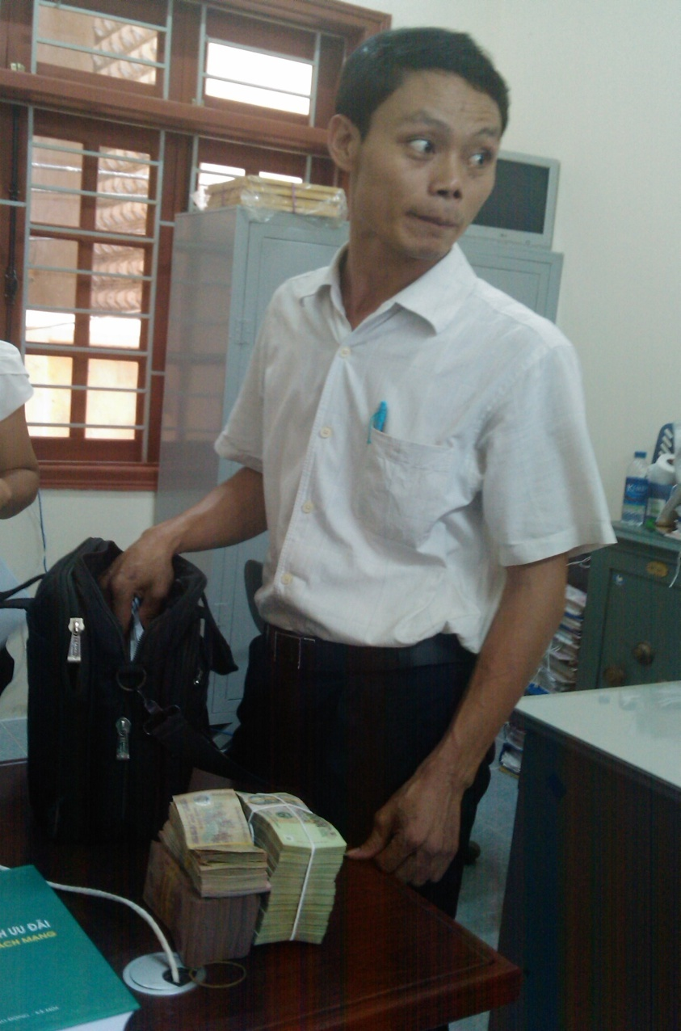
Photo3: A commune social officer is collecting cash at the district office to deliver to ethnic minorities beneficiaries under an existing cash transfer scheme, which is reportedly subject to risks of safety and abuses.
Three of the four pilot provinces, namely Ha Giang, Quang Nam and Lam Dong, have undergone some experiences in payment of different kinds of cash benefits through the Post Office. Therefore, respondents, officials and beneficiaries alike, can share some of their perceptions of the delivery mechanism that the SASSP is planning to use. Ha Giang has piloted payment of Decree 67/13 benefits through VN Post in Ha Giang City since September 2011, and in Dong Van and Yen Minh districts since June 2012. In Lam Dong piloted payment of Decree 67/13 benefits in Da Lat City and Duc Trong district since July 2012, and has expanded the scheme across the province since January 2013. Generally, local stakeholders and beneficiaries have acknowledged positive impacts from the payment delivery by the Post Office, such as convenience, transparency, and safety.
The respondents have reported some concerns as identified in the pilot period, including the commitment of VNPost staff who are on short-term contracts and nominated by the commune authorities, poor material and human resources, particularly in financial management, safety in cash collection for payment and storage conditions at the commune post office, paper-based documentation, long queues in a limited number of payment days, as well as verification of beneficiaries. For example, Ha Giang has 26 communes without a post office, and Quang Nam has 138 out of 162 commune post offices in operation. Regarding the availability of cars for postal transport, Lam Dong has 40, Quang Nam 34, Quang Ngai 17, and Tra Vinh only 4.
Communication and awareness/outreach
A better understanding of the existing flows of information among EM communities would inform the designing team to look for accessible procedures appropriate to the culture of beneficiary groups under the SASSP to address their grievances arising from the project implementation. It also enables the team to prepare mechanisms and benchmarks appropriate to the project for monitoring, evaluating, and reporting during the implementation process. It is aimed to ensure arrangements for the free, prior and informed consultations with the EMs in the project areas. Below are some conventional downward and upward flows of information in the visited project areas.
Downwards,information is often communicated through the following channels:
- Upon receiving implementation guidelines, the commune authorities organize a meeting to discuss an implementation approach with village leaders and relevant stakeholders at the commune level. Afterwards, village leaders meet up with village-level key stakeholders to discuss implementation methods and organize meetings with villagers to reach agreement on a detailed implementation approach. This is the most common and effective channel of communication. However, in Ha Giang, commune officers serve as the most popular channel of communication;
- In some areas, mass organizations do not have clear roles in communication, thus the information flow through this channel is often weak and thus only implemented through village meetings;
- Credit groups may effectively relay some information but mainly regarding their areas of operations and coming from the commune authorities;
- Bulletins at the Commune’s People’s Committee (rarely read);
- National or sub-national TV (but in Ha Giang, a number of villages have no access to electricity);
- Radios (available in a few households nowadays);
- In Ha Giang, public loudspeakers are available but not in all villages. Moreover, public speakers and flyers are inefficient in some cases as many EM people are not fluent in Vietnamese; and
- Rumors play an important role in some cases.

Upwards,information, especially when citizens have queries or seek advice, is often communicated through the following channels:
- Official channels include feedback to village leaders, questions, and legal claims at the commune people’s committee;
- Some citizens may meet village cadres (usually the head) who may refer their issues to the commune people’s committee (chair or vice chair) if they fail to address;
- Better-informed citizens may come directly to the commune people’s committee and meet up with the social officer, or the chair or the vice chair of the committee (at regular reception sessions);
- Some may visit the District Division for Labour and Social Affairs (DivLISA), or the district people’s committee leaders (DPC) at a weekly reception session, or the director of the DPC administrative office;
- Citizens report problematic cases and concerns on local TV and radio, or directly to DoLISA. The Senior Citizens Association also report problematic cases that happen to their members, for instance exclusion errors; and
- Information is shared with relatives who hold certain positions at the village and commune levels.

Some groups that remain excluded from information and participation:
- ethnic minorities citizens with no or limited Vietnamese.It is found difficult to communicate policy issues in the H'mong community, as many H'mong people do not understand Vietnamese. In many cases, village chiefs and commune officers fill out application forms for those who cannot do so in Vietnamese;
- ethnic minorities citizens with no or limited education. In Ha Giang, the H’mong language is spoken at community meetings as all residents are H’mong, except a couple of cadres. Many meeting participants may not understand all information provided;
- women who tend to care about benefit policy more than men but do not have much free time to attend public meetings or follow the media;
- poor citizens who spend most of their time on livelihood for survival;
- migrants who are not invited to community meetings or members of mass organizations, nor visit the commune’s people’s committee.

Some common reasons for no or poor access to information are identified at the consultations, such as not attending community meetings; not joining mass organizations; not reading printed news bulletins or bulletin boards at CPC; and not being informed by community chiefs. Moreover, qualification of local authorities remains unsatisfactory. Most of the village leaders have not finished secondary education, and some of them are even not fluent in Vietnamese. It is therefore difficult for them to comprehend and explain guidelines and policies issued by the government to other people. Some community heads are not fully aware of the policies/programmes or just provide information without caring whether the information reaches certain eligible citizens. For instance, in Ha Giang, DivLISA staff and commune officers, after being trained at the provincial level, cooperate with legal officers to disseminate information at village meetings held once or twice per month. Usually, a commune officer is responsible for several villages and may explain to them. If problems arise, DivLISA staff may come to villages for further explanation. However, in Meo Vac district, Ha Giang, DivLISA managers are unsure about whether the information, communicated to village heads verbally in most cases, can reach citizens properly at the village-level. Furthermore, in some areas, even DivLISA staff fail to understand social policies properly.
Complaints and grievance redressal
The respondents identify some concerns over the current complaints and grievance redressal mechanism in general and for cash transfer schemes in particular at the local level, which serve as useful references for improving the system during the implementation of the SASSP:
In Ha Giang, complaints are made verbally, chiefly at community meetings. Commune officers who attend the meetings relay information to CPC leaders, or to the commune’s communist party secretary, the CPC chair, and other relevant commune officers. But few complaints have been received. Alternatively, the commune officer in charge of the village may advise citizens to go to CPC or DPC. Legal aid centers collect information (many petitions) and its collaborators (staff of DoLISA) send collected information to relevant divisions for responses. In Da Ron commune, Don Duong District, Lam Dong, two judicial officers are overworked, which negatively impinges upon their quality of disseminating legal knowledge and providing legal aid for EM groups.
Mediation groups at the commune and village levels face constraints. They are overloaded with settling issues related to the Land Law, marriage, and other civil affairs while their experience and knowledge are insufficient, especially their knowledge and skills in legal practice. Therefore, it would be hard to equip them with more knowledge of the process of feedback and social assistance policies. Another concern is their understanding, communication of, and adequate guidance on legal issues to EM people.
District inspectors usually do not have time to open the letter box at the DPC. The letter box based at Ma Le CPC, Dong Van, Ha Giang has not been opened for a couple of years. It remains unclear who is held accountable for opening the box and when it should be opened. No minutes of opening nor witnesses are stipulated. From 2008 to 2012, only five complaints were submitted in Don Duong district, Lam Dong, and none in Dong Van district, Ha Giang. At the commune level, there are no formal written complaints. The main reasons for limited feedback are a lack of understanding the rules and process, especially amongst EM groups, and inadequate knowledge of local officials. Some respondents report that they sometimes do not know whom to reach for questions and advice, citing an apparent distance between local officials and the people as another reason.

Photo 4: An empty letter box which is believed not to reflect the actual demand in Da Ron commune, Don Duong district, Lam Dong, where a great number of K’ho people are living.
Monitoring and evaluation
As the consultant team attempted to collect some background information on the project sites, such as the availability of and access to schools and clinics as well as other services, such data were hard to collect, because of unavailability, or lack of understanding the significance of monitoring data to the improvement of local services and long-term poverty reduction planning or lack of dedicated staff. Furthermore, a concern over the enforcement and monitoring of policy implementation has been raised. Decree 49 Scheme is a conditional cash transfer but many local officials do not seem confident that poor households would give priority to spending on children, especially the latter’s food and learning facilities. In addition, students now have many options of schools to attend. Many students go to schools outside their reference system, for instance in a commune different from where they live. Therefore, monitoring the implementation of co-responsibilities amongst beneficiary households is viewed as the biggest challenge.
No systematic monitoring and evaluation of impacts of cash transfers have been in operations in the visited sites. Although the provincial authorities may issue inter-departmental guidance which stipulates departmental responsibility for monitoring cash transfer schemes, only reports on outcomes of implementation are produced, no reports on monitoring available. Due attention has not been paid to generating and maintaining electronic data. Commune officers remain unaware of the significance of electronic database on social assistance. In fact, a computer is considered more or less a typewriter. Some electronic data are removed after a short period of computer storage. Personal records of beneficiaries are kept in paper forms at DivLISAs. In many communes in Ha Giang, a province with a great majority of population being ethnic minorities, data are produced and stored chiefly in paper forms in CPCs due to limited availability of computers and poor computer literacy. Usually, in some communes, usually in towns, only the ward’s women’s union are required by their higher level of authority to monitor whether student-recipients of scholarships continue going to school and how they perform in school, or whether loan-recipient households have their living conditions improved. They have to submit an annual progress report of beneficiaries to the higher level of authority.
In Ha Giang, DoLISA has a working mission that may check three or four districts (and their communes) per year regarding different tasks, including delivery of social assistance. The mission in Ha Giang is organized twice a year, half day per district. Issues are reflected at regular review meetings, half-year and year-end meetings. Sectoral divisions within DoLISA also have checking missions (twice a year, which district to visit may depend on the routes of journeys, usually focus is laid on districts with poor performance).At the district level, results of provincial-level monitoring missions are reported to DoLISA. DoLISA management and its specialist divisions have to respond and settle reported cases with written instructions according to their jurisdiction and the Inspection Law (regarding time and reporting system). Requests are sent to DPC for implementation and verification. If cases are found wrong, DPC asks for settlement and verification with the sectoral inspection division, and compensation. DPC has the responsibility for monitoring as part of state management functions. Expenditures can be checked by DivLISA and DivFin through a list of recipients approved by DPC. DivLISA keeps evidence of payment with recipients’ signatures.
At the commune level, the People’s Council has monitoring visits every quarter in all areas of work, such as national defense, culture, economy, and social policies. They visit all beneficiaries and ask them what and how to receive benefits. If errors are found, they are reported to the CPC chair for instructions on handling. S/he may ask village cadres to review problematic cases. But no such cases so far. The People’s Council meets twice a year to develop monitoring plans. It has a network of village collaborators who report problems to the People’s Council which later requests CPC to consider. Staff of Vietnam Fatherland Front(VFF) often come to villages before the People’s Council’s visits to inform of the latter’s monitoring contents. VFF also joins the People’s Council’s mission and has no separate monitoring mission (as in other localities). Information from M&E missions are used chiefly for administrative reporting. A village has a People’s Inspection Board headed by VFF with membership including heads of village-level societal organizations (chi hoi truong). The board does not meet up regularly. The board may ask village chiefs to explain issues in culture, economy, implementation of social policies, and grassroots democracy. It monitors day-to-day affairs at the grassroots level and reports public concerns, including those about social assistance, to the CPC chair and VFF who later ask for handling directions from the Party Secretariat.

VI. Recommendations
This section highlights strong messages that come from the free, prior and informed consultations with potential beneficiaries and other respondents in villages and at sub-national levels of administration, especially to address the constraints as identified in the sections above.
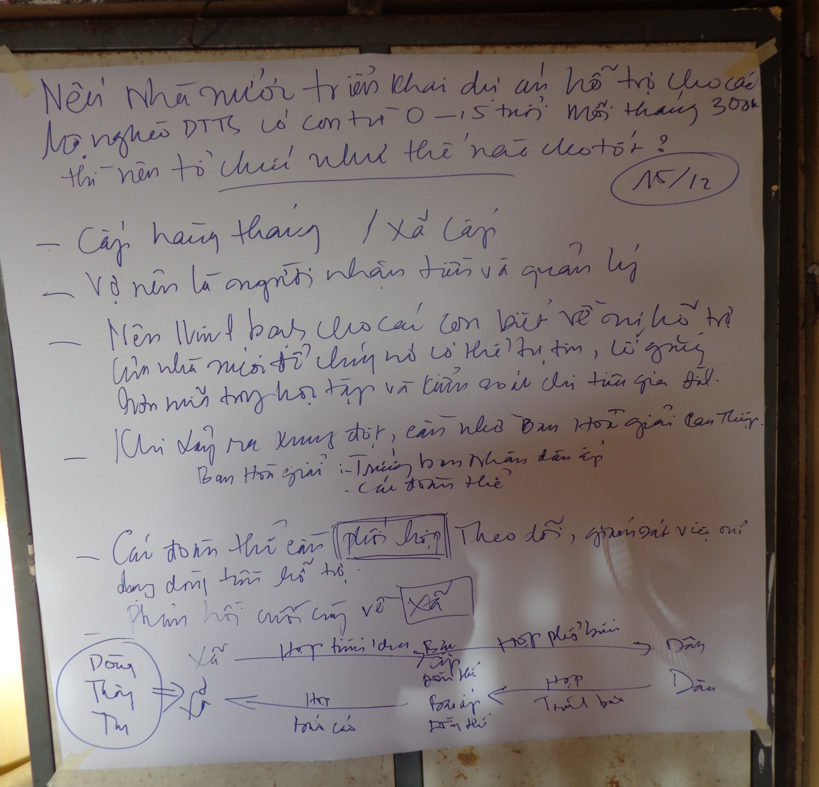
Photo 5: A consultative session on local recommendations to address the constraints in the delivery mechanism, minimize potential negative impacts as well as maximize potential positive impacts of the SASSP.
This section highlights strong messages that come from the free, prior and informed consultations with prospective beneficiaries and other respondents in villages and at sub-national levels of administration, especially to address the constraints as identified in the sections above.
Photo 6: A consultative session on local recommendations to address the constraints in the delivery mechanism, to minimize potential negative impacts as well as to maximize potential positive impacts of the SASSP.
  - The culture of dependence and targeting

- It is essential to obtain beneficiaries’ written commitments on their willingness to seek advice from village collaborators on the use of cash benefits according to the project objectives;
- Cash benefits should be time-bound or may be terminated as improvements have been recorded in beneficiary economic conditions;
- An effective exist strategy: There should be a certain period for poor households to graduate from poor to near-poor households so that they may not face shocks when being lifted out of the poor list. Government support should be expanded to households who have just been lifted out of poverty. By doing so, they may escape poverty in a sustainable manner and will not envy other people in the poor list;
- It is important to improve the targeting approach in a more adequate and impartial manner to minimize exclusion and inclusion errors. The training of local officials, social collaborators and service providers will be culturally appropriate and gender sensitive. The SASSP will identify specific gaps through an assessment of training needs and develop an appropriate training strategy and materials to ensure that the project activities are undertaken in an inclusive and culturally suitable manner;
- Sanctions against violations: Certain warnings or penalties, depending on the levels of violations should be imposed on violations. Strong preference for strict monitoring of co-responsibilities;
- Transparency: the poor list should be communicated in a manner fully accessible to EM people, especially in terms of language and culture. Various measures and initiatives should apply depending on local socio-cultural conditions;
- Capacity building: The training of local officials, social collaborators and service providers will be culturally appropriate and gender sensitive. The SASSP will identify specific gaps through an assessment of training needs and develop an appropriate training strategy and materials to ensure that the project activities are undertaken in an inclusive and culturally suitable manner.

  - Communication, outreach, and beneficiary utilization of social services

- The project communication strategy and local information campaigns will be customized to address the specific needs of different EM groups in terms of language and cultural relevance. The design of the communication strategy will take into account differences in how information is disseminated among different EM groups and leverage the presence of credible traditional institutional structures and formal and informal EM organizations in the project areas for dissemination. In addition, the use of village social collaborators allows providing support and counseling to EM beneficiary households in their language and culturally appropriate way. The social collaborators will be actively encouraged to support particularly hard to reach or vulnerable beneficiary households;
- In order to identify approaches, communication methods and particular policies to deal with the situation, local authorities have used and brought into play the role of hamlet and village medical staffs as well as community mass organizations/unions. These people and organizations are mainly EM people who are living in the EM areas; therefore, they have been active in communicating and popularizing relevant policies/programmes to local people. Collaborators and mass unions/groups in hamlets and villages are unpaid; however, if there are programmes, they will participate in them actively and effectively;
- The village collaborators will be identified from the local communities and will be selected and trained in a manner that they are sensitive to the needs and culture of the different EM groups in their area of operation. The parenting support strategy and materials will also be designed taking into account the cultural differences in parenting behaviors among different EM groups and specific behavioral changes to be addressed.
- To expand the utilization of social services amongst EMs in general, and EM beneficiaries under the SASSP in particular, it is important to develop an adequate C4D strategies to boost both demand from beneficiary households and advocacy for stronger commitment from the local authorities in addressing constraints in supplying adequate social services. The C4D strategy and the Operations Manual, which are being drafted under the SASSP, have taken into account the constraints and emerging requirements that have been reflected in the local consultations in order to avoid exclusion of the EM groups from the projects and its benefits and ensure continued free, prior and informed consultations with them during the project implementation.

  - Payment and spending practices

- Benefit payments would be made through an independent payment agency at fixed times (monthly) and at a fixed location, making it more predictable and convenient for poor EM beneficiaries. Payments would be made to and managed by women in beneficiary households. Village collaborators will monitor and check. In the future, technology improvement may enhance transparency. For example, information on payment will be made to village collaborators. Illiterate collaborators may be provided with assistance from literate members of their households, neighbors or village collaborators;
- Collaborators should also be women (to be recruited from the Women's Union; or village health and nutrition collaborators, etc.). However, the final decision should be left for each province, depending on their current contexts; and
- In some areas where village elderly still play an important role, such as in the H’mong communities in Ha Giang, village collaborators may be advised to convey some messages through the village elderly. Concurrently, it is essential to consider how improve the feedback mechanism for H’mong women, especially young ones, to the village elderly as the latter seem to discount the former’s voice at the moment. The terms of reference (ToR) for village collaborators, the framework agreement with payment service providers and the Operations Manual, which are being drafted under the SASSP, have taken into account the constraints and emerging requirements that have been reflected in the local consultations in order to avoid the exclusion of the EM groups from the project and its benefits and ensure continued free, prior and informed consultations with them during the project implementation.

  - Monitoring and evaluation

- Community oversight system: Representatives from village-level mass organizations, such as the Youth’s Union and the Red Cross Society, should be involved in monitoring the use of cash benefits; It is also important to involve informal institutions such as the Parents’ Associations, the Education Encouragement Association, village elders (in areas where village elders still have important roles to play, such amongst the H’mong and K’ho communities) and school students themselves in monitoring the fulfillment of the proposed co-responsibilities;
- The monitoring of beneficiary co-responsibilities is more difficult than that under the Government Decision 49 Scheme. Therefore, the network of collaborators should be fine-tuned and include village collaborators for health, population and nutrition. Concurrently, measures to improve the linkages between schools, families and mass organizations are needed; and
- Monitoring indicators related to EMs’ accessibility and oversight: The SASSP’s expected outcomes will be monitored and measured as part of the result framework, as well as through a process evaluation of the service delivery innovations piloted through the Opportunity program. These monitoring and evaluation arrangements for the project will include indicators that allow analysis disaggregated by gender and ethnicity.The local assessment has identified some constraints in local statistical data. For instance, it is essential to disaggregate ethnic groups in the poor list by adding more codes for other minorities that are not recorded in the current poverty census/survey questionnaires (Form C) to include the missing ones, as instructed by MoLISA. A community satisfaction survey is planned to take place in an adequate time during the implementation period to understand emerging constraints and make timely necessary adjustments in order to avoid exclusion of the EM groups from the SASSP benefits.
- The MIS and the national registry, which will be established under the SASSP, are expected to address many of the constraints as identified in the consultations. Other important indicators that may need recording and monitoring include the share of eligible households receiving benefit payments through the new system, the share of beneficiaries reporting satisfaction with selected social assistance programs in participating provinces, and the share of beneficiary households who report using good parenting skills.

  - Governance-related issues

- An effective feedback mechanism:It is important to improving the existing mechanism and apply initiatives. In particular, it is necessary to improve the flows of information, downward and upward alike, to create more favorable conditions for the EMs to be engaged in the feedback mechanism in order to avoid exclusion of the EM groups from the project and its benefits and maximize the positive impacts on and satisfaction of project beneficiaries. Grievance redress mechanisms will be adapted to the needs of the specific EM groups in terms of language and cultural norms on complaints. In doing so, the SASSP will enable the EM groups, including those with weak political connections, to register complaints. The initiatives, such as the use of a hotline for queries and complaints regarding social assistance, are being considered. The proposed feedback mechanism and the Operations Manual, which are being drafted under the SASSP, have taken into account the constraints and emerging requirements that have been reflected in the local consultations to ensure continued free, prior and informed consultations with EM beneficiaries during the project implementation.
- Incentives for Government officials for participation and inclusion: To incentivize government officials to participate more actively in theprocess, it is essential to use certain indicators ofpoverty reduction amongst EMs as measurement of their performance. It is encouraged to develop local EM leadership as field visits during the social assessment demonstrated the value of EM officials from the local community in terms of promoting participation from and inclusion of EMs in local development initiatives. As the social assessment points out, EM officials serve as active agents who can effectively link the local government and the people in different domains, and can provide assistance for Kinh colleagues in policy implementation. The C4D strategy should bring this issue to attention. Other incentives include various training opportunities and field visits to learn useful experiences from other provinces;
- Social demand for accountability and transparency: To support the social demand for accountability, it is vital to strengthen the capacity of project beneficiaries through various measures and initiatives, some of which have been mentioned elsewhere in this report, such as regular development sessions led by village collaborators and parent leaders with well-prepared C4D materials; a more effective feedback mechanism; as well as enhanced transparency of the poor list to EM people, and capacity building for local officials, village collaborators and service providers.
- Promotion of local and international NGO programs that involve EM communities in their work. The work of international NGOs has made noticeable development impacts in Quang Nam and especially Lao Cai since the 1990s. Vietnamese NGOs have formed in major cities and some provinces, but are not yet common in EM areas. In Lam Dong, very few NGO projects are present of any kind. NGO programs can add value to poverty reduction efforts in EM communities through introduction of more participatory planning processes, environmentally sustainable agricultural models, education and health capacity development, among other areas. One way to support civil society development in ethnic communities, as well as carry out others of the above recommendations, would be creation of a provincial innovation fund or small project facility, similar to the national Innovation Day, to which communities, mass organizations and NGOs could submit proposals for funding.

  - Framework for ensuring free, prior, and informed consultation with affected EM communities during project implementation

During project implementation, as a principle of ensuring inclusion, participation and cultural suitability, the project will hold continuous consultations including soliciting feedback from all communities so that remedial actions can be taken to support improved participation and provision of benefits to households including those of EMs. The consultation methods to be used are appropriate to social and cultural traits of EM groups that the consultations target, with particular attention given to beneficiaries, local officials, village leaders and service providers. They will be provided with relevant information about the project in a culturally appropriate manner during project implementation, monitoring and evaluation to promote their meaningful participation and sense of ownership. In addition, the inputs/information used for monitoring and evaluation (such as beneficiaries enrolled in the Opportunity program and receiving benefits, etc.) will have participation of relevant EM stakeholders. By enabling participation of relevant EM stakeholders during project planning, implementation, monitoring and evaluation, the project can ensure that EM people receive social and economic benefits that are culturally appropriate to them. In doing so, the cash benefits and the support provided by the village collaborator network through the project are expected to contribute to long-term poverty reduction and improvements in human development outcomes among EM groups.

Annex 1: Local Access to Basic Social Services

A1. Access to Healthcare Services

At the provincial and district levels, services provided by local hospitals and clinics and sanitation and anti-epidemic teams can meet local people’s basic needs of health check-up and treatment. Most of the visited communes/wards have their own clinics with midwives or obstetric nurses while village health points have their own medical cabinets. At the grassroots level, medical services mainly depend on village population and health collaborators. Clinics are facing constraints in both staff’s qualification, capacity, and trained skills. Furthermore, many commune clinics do not have their own doctors. Quang Nam does not seem to have fared well in supplying medical services, with six communes without clinics, and more than two-thirds of its communes without doctors.
Material resources
- At the commune level, the visited commune clinics have been in fairly good conditions, equipped with relatively satisfactory facilities, although they do not enough eight patient rooms according to the national standards, nor do they have an ultrasound machine.
- At the village level, most of the visited villages have community medicine cabinets with five common medicines, namely Paracetamol, DutinC, Becomlet, Amocilin, and Autuxin but some villages (in Quang Nam) do not.

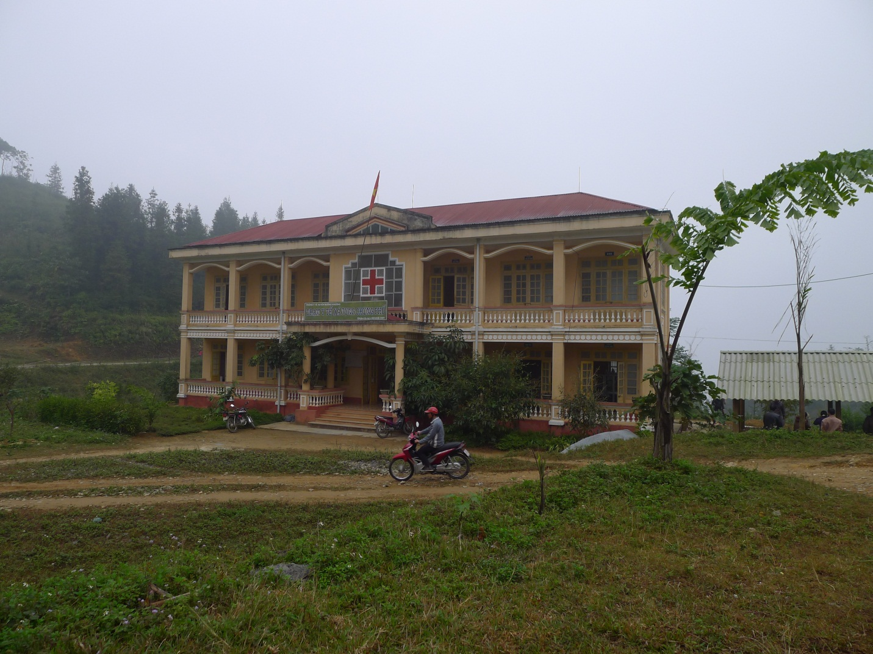
Photo 7: Acommune clinic in Tung Chung Pho commune (Muong Khuong district, Lao Cai) where a large proportion of EM people, especially H’mong and Dao, are living.
Table 4. Healthcare at the provincial level (in percentage)

Province | Rate of the communes having no health clinic (%) | Rate of the communes having no doctor (%) | Rate of the communes having no midwife or obstetric - pediatric nurse (%) | Rate of under-one-year-old children fully vaccinated (%) | Rate of under-five-year-old malnourished children (%)
Ha Giang | NA | 57.2 | 0 | 95.45 | 18.37
Quang Nam | 2.5 | 72.54 | 0 | 96.9 | 16.7
Lam Dong | 0 | 33.4 | 0 | 97.6 | 16.8
Tra Vinh | 0 | 22 | 0 | 97.5 | 10.8
Source: The local capacity assessment, ILSSA, 2012
Human resources
- The operations and quality of commune healthcare networks and village population and nutrition collaborators have been improved despite many constraints. Clinic staff, including medical doctors, pharmacists and nurses, have undertaken professional training.
- In the visited villages, most of the healthcare staff have attended some short-term training courses so they can diagnose and monitor popular symptoms and diseases. They can collaborate with higher-level colleagues in engaging the local people in community healthcare programs and universal immunization campaigns for children, as well as providing maternity care and immunization services for pregnant women. Particularly, village health collaborators have undergone a six-month nursing course in district towns, organized by the Provincial Health Department. Given their advantages of having trained competencies, village health collaborators often play the additional roles of collaborators for population and nutrition.
- In Ha Giang, more than 85 percent of the village collaborators for population issues, healthcare and nutrition are men as they usually have better education and more time freed from household chores. Many of the H’mong women have not completed primary education although the situation is believed to have changed since H’mong girls now enjoy more opportunities to study as a result of improved household living standards and enhanced awareness of the role of education.
- In Lam Dong, more than 65 percent of the village collaborators for population issues, healthcare and nutrition also perform the roles of heads and deputy heads of village-level mass organizations. This situation has certain implications for designing the linkage model for the SASSP village collaborators.
- Under a project implemented in some provinces, including Ha Giang, girls who have completed at least lower secondary education and express their desire to join the project have been trained as village midwives in a nine months’ intensive course. Following the completion of the project, most of them have been employed as village collaborators for population issues, healthcare and nutrition. In Tra Vinh, two of the visited clinics have no mid-wives, therefore most of the deliveries are transferred to Tieu Can district hospital. Difficult deliveries or cases of serious illness may be transferred to Trà Vinh Provincial General Hospital. In Tra Bong district, Quang Ngai, the visited commune clinics lack staff qualified as doctors and prenatal care specialists. As a consequence, most of the pregnant women travel to the district hospital for delivery.
- Collaborators for healthcare and nutrition usually have better training than other colleagues at the village level. The selected candidates should have completed at least primary education and be provided with three to nine months of training. In addition, they have a chance to be re-trained every year.

A2. Access to Education

The general education system in the visited sites has a larger coverage than the health system. For the implementation of the National Programme on Illiteracy Elimination, Universalization of Pre-school, Primary and Lower Secondary Education, school facilities, such as teaching and learning equipment, have been upgraded to fairly good conditions in some areas.
Material resources
- The preschool system is facing the biggest challenge, with more than 15 percent of villages without kindergartens in Quang Nam. The rate amounts to 28.7 percent in Lam Dong. All districts have higher secondary schools; most of the visited communes have both primary and lower secondary schools. The communes in Quang Nam are in the most difficult circumstance, with four without primary schools and as many as 31 without lower secondary schools.
- An average distance from a farthest household to a primary and lower secondary schools is between 2 and 3-5 kilometers, respectively. In addition, the average distance from a farthest household to a satellite school is 3 kilometers. However, in northern mountainous communes where transport is difficult, children’s access to lower secondary schools remains poor.
- In mountainous communes in Ha Giang, preschool and primary school satellites are located in in different villages where village-based teachers are involved not only in imparting knowledge but also in persuading parents to send children to schools. In many cases, teachers come to households and collect children to schools. Preschool classes can accommodate most of the children at this age. In a number of primary schools, however, some classes of different grades still share rooms.

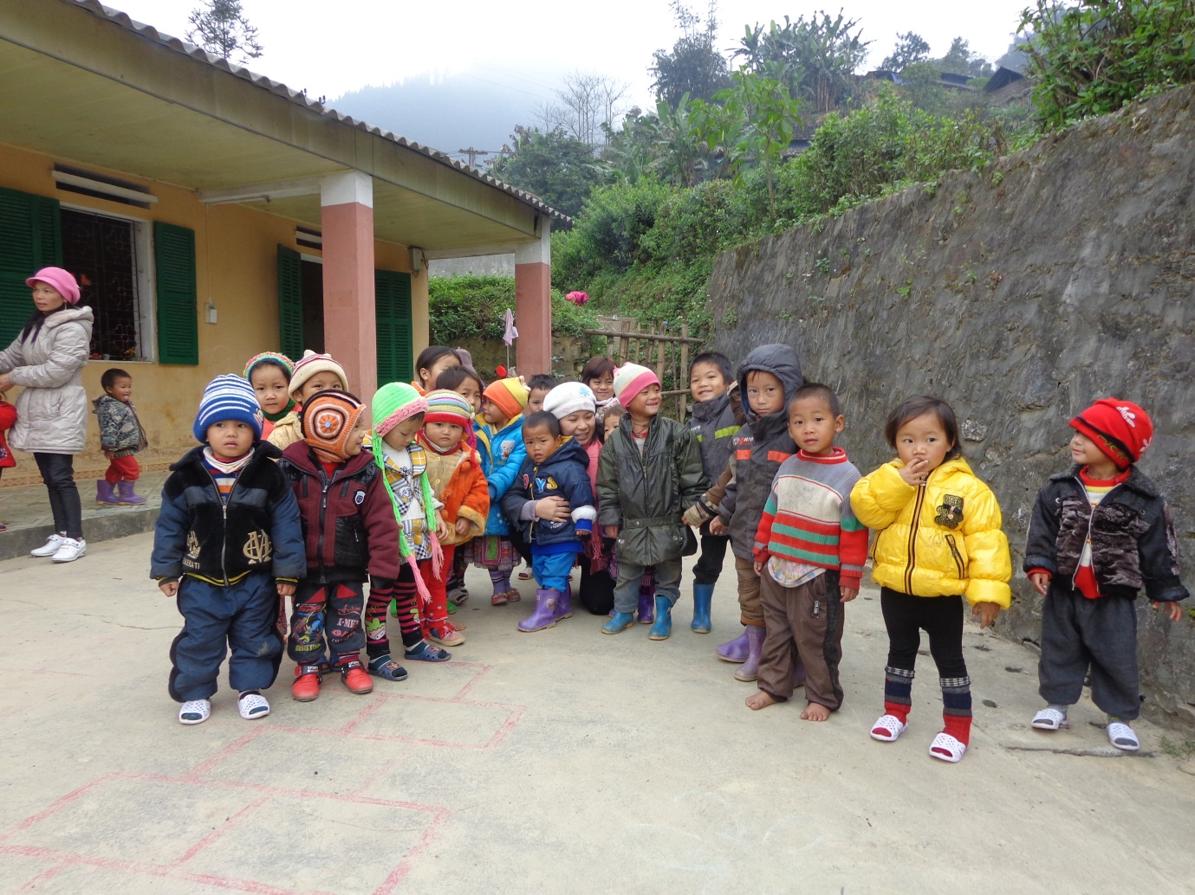
Photo 8: A preschool satellite in Tung Chung Pho commune (Muong Khuong district, Lao Cai) where a large proportion of EM people, especially H’mong and Dao, are living.
Human resources
- According to official reports from the local education sector, a great majority (all in many cases) of the teachers in commune-level schools have reached national standards. Respondents have no complaints about the quality of education services in general and of teachers in particular.
- However, some district and commune officials cast their doubt over the linkage between annual pass rates and the local education quality: “Every year, the education sector paints a rosy picture but in reality, some fourth and fifth graders have not achieved basic functional literacy.” (In-depth interview with an official from the Ethnic Minorities Division, Tieu Can district, Tra Vinh).

Enrollment rates
- Although the policy on universalizing primary education has been effective for a long time, the net enrollment rate for primary education remains lower than planned. In Ha Giang, the net enrollment rates of children aged two or less, three to five, and six to 14 are 26.3, 92.6 and 98.13 percent, respectively.
- According to both the official report and anecdotal evidence, in some communes in Tra Bong district, Quang Ngai, child labor remains fairly common, and students from junior secondary schools are observed to have low commitment to study.
- In some villages in Quang Ngai, respondents report that many children would not go to schools in case of no cash subsidies for their households.

Table 5. Enrollment and drop-out rates at the provincial level (in percentage)

Province | Communes without kindergartens (%) | Communes without primary schools (%) | Communes without lower secondary school (%) | Districts without high school (%) | Children aged 3-5 going to pre-schools (%) | Net enrollment rate at primary level (%) | Lower secondary enrollment (%) | Drop-out rate at the primary level (%) | Drop-out rate at lower secondary level (%)
Ha Giang | NA | 0 | 40 | NA | NA | NA | NA | NA | NA
Quang Nam | NA | 1.5 | 16.1 | 0 | 68.9 | 95.5 | 87.4 | 1.9 | 2.5
Lam Dong | 28.7 | 0 | 1.4 | 0 | 75.2 | 90.5 | 90.0 | 0.1 | 0.5
Tra Vinh | 11.6 | 0 | 0 | 0 | 68.4 | 92.0 | 85.0 | 0.2 | 1.7
Source: The local capacity assessment, ILSSA, 2012

According to the poverty lines (adopted by MoLISA) applicable for the 2011-2015 period.
The data come from the provincial official reports updated by late 2012.
They include the CPC chair, the social officer, and representatives from mass organizations.
The current questionnaires provide 14 codes for EMs, many of them are considered having larger populations and better living conditions. They are Kinh (1), Tày (2), Thái (3), Hoa (4), Khmer (5), Mường (6), Nùng (7), H’mong (8), Dao (9), Gia Rai (10), Ng¸i (11), Ê đê (12), Bana (13), and Xê đăng (14).
For instance, Can Đăng village is only 35km away from Trà Vinh Provincial General Hospital, with easily accessible transport.

